Learning Strategies 10 - 12
Grade 10 & 11 ONLY
Cartoon Analysis
mreeves@nspes.ca

Cartoon Analysis

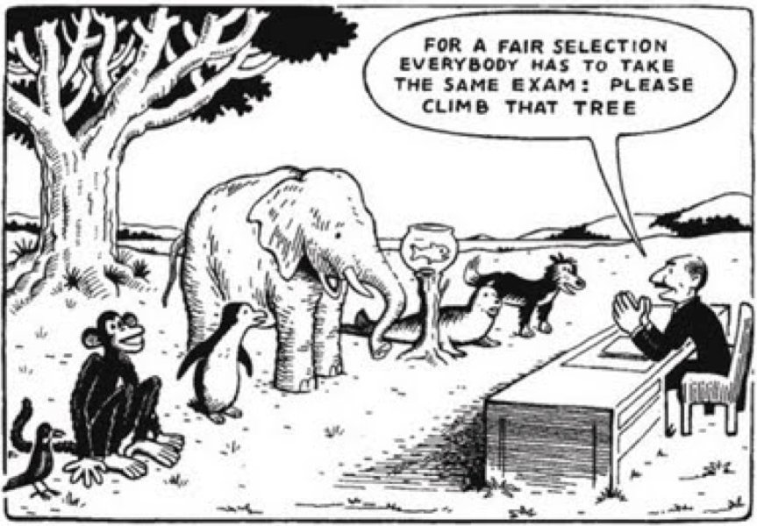

Task: Study the following cartoon. Discuss with classmates and your friends the meaning of the cartoon. Write a 300 - 400 word response and reflect on the following questions.

- What does this picture say about fairness and equality?
- How does this relate to you?
- How can this relate to your learning?
- How can this be changed?
- How do you intend to advocate for yourself in the classroom?

